System and Software Architecture Description (SSAD)

Mission Science Information and Data Management System

Team#06

Celia Kung -- Project Manager
Hardik -- Shah Feasibility Analyst
Kathleen Barrera -- Quality Focal Point (QFP)
Zhenlu Sun -- Requirements Engineer
Yujie Chen -- Prototyper
Brian Anderson -- Operational Concept Engineer
Wei Tan – Software Architecture Designer

12/12/2011

Version History
Date | Author | Version | Changes made | Rationale
10/10/11 | Yujie Chen | 1.0 | - Original template for use with Instructional ICM-Sw v1.0 | - Initial draft for use with Instructional ICM-Sw v1.0
10/14/11 | Yujie, Hardik | 1.1 | - Update All the UML Class Diagrams and all the tables(Some table numbers are not correct as we are working on the tables as suggested by TA in the core FC package) | - Use RSM to model all class Diagrams
10/23/11 | Wei Tan, Yujie Chen | 1.2 | - Modify part 2.1.3, sort the User Case in the right order | - Inclusion for DC package
11/20/11 | Wei Tan, Yujie Chen | 1.3 | - Split user cases in more elaborate way, restructure the document.  - Finished section 3 | - According to comments, corrected defects in SSAD document  - FOR Draft TRR package
12/04/11 | Yujie chen | 1.4 | - Added ER diagram that containing all fields of tables which are user friendly | - For TRR package
12/12/11 | Yujie chen | 1.5 | - Removed the duplicated actors in use case  - Corrected the use case diagram | - For final deliverables

Table of Contents
System and Software Architecture Description (SSAD) i
Version History ii
Table of Contents iii
Table of Tables iv
Table of Figures vi
1. Introduction 1
1.1 Purpose of the SSAD 1
1.2 Status of the SSAD 1
2. System Analysis 2
2.1 System Analysis Overview 2
3. NDI/NCS Interoperability Analysis 20
3.1 Introduction 20
3.2 System Structure 20
3.3 Evaluation Summary 21

Table of Tables
Table 1 Actors Summary 3
Table 2 Artifacts and Information Summary 6
Table 3 Process Description-Add Project 7
Table 4 Typical Course of Action-Create new project 8
Table 5 Process Description-Edit Project 8
Table 6: Typical Course of Action- Edit project 8
Table 7: Process Description-Delete Project 8
Table 8: Typical Course of Action- Delete project 9
Table 9: Alternative Course of Action- Incomplete Form 9
Table 10: Process Description – Add Student Information 9
Table 11: Typical Course of Action – Add Student Information 10
Table 12: Process Descriptions – Edit Student Information 10
Table 13: Typical Course of Action – Edit Student Information 10
Table 14: Process Description – Delete Student Information 11
Table 15: Typical Course of Action – Delete Student Information 11
Table 16: Process Description- Refer project to book 12
Table 17: Typical Course of Action-Refer project to Book 12
Table 20: Process Description-Generate Report 12
Table 21: Typical Course of Action-Generate Report 13
Table 22: Process Descriptions - Login 13
Table 23: Typical Course of Action – Login: Successful 13
Table 24: Alternate Course of Action – Login: Failure 14
Table 25: Process Descriptions – Logout 14
Table 26: Typical Course of Action – Logout 14
Table 27: Process Description-transfer items between inventories 14
Table 28: Typical Course of Action- transfer items between inventories 15
Table 29: Alternative Course of Action- Incomplete Form 15
Table 30: Process Description-consume items in inventories 16
Table 31: Typical Course of Action- transfer items between inventories 16
Table 32: Alternative Course of Action- Incomplete Form 16
Table 33: Process Description- Attach picture to item 17
Table 34: Typical Course of Action- Attach picture to item 17
Table 35: Process Description- Update student attendance using attendance sheet 18
Table 36: Typical Course of Action-Update student attendance using attendance sheet 18
Table 37: Alternative Course of Action- Incomplete Form 19
Table 38: NDI Products Listing 20
Table 39: NDI Evaluation 21

Table of Figures
Figure 1: System Context Diagram 3
Figure 2: Artifacts and Information Diagram 5
Figure 3: Entity Relation Diagram 6
Figure 3: Process Diagram 7
Figure 4: Deployment Diagram 20
Figure 5: Software Component Diagram 21
Figure 6: Hardware Component Diagram 21

Introduction

Purpose of the SSAD

The purpose of the SSAD is to document the results of the object-oriented analysis and design (OOA&D) of the system being developed. The SSAD is used by the builder (programmer) as reference to the system architecture. The system being developed should be faithful to the architecture specified in the SSAD. Furthermore, the SSAD is used by the maintainer and clients to help understand the structure of the system once the proposed system is delivered.

Status of the SSAD
Version 1.4:
Added the Entity Relation Diagram in to this document;
This is the final version of SSAD document.

System Analysis

System Analysis Overview
The primary purpose of Mission science information and data management system is to keep track of Inventory, lesson plan, students, so that administrator can better manage his budget and improve their teaching quality. By allowing administrator to perform longitudinal study based on the data, he can output more detailed and accurate report than it used to be. The proposed goal will be realized by integrating 5 different databases, and we are going to develop friendly user interface to enhance both the efficiency and durability of the system.

System Context
Figure 1 shows operational context of the Mission Science Data management System.

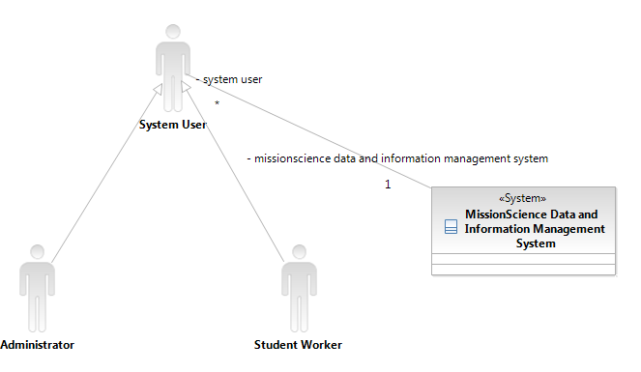
Figure 1: System Context Diagram
Table 1 Actors Summary
Actor | Description | Responsibilities
System User | Has profile in system, can be either an Administrator or a student worker | - Operate the system and manage the data in the system.  - Check in and check out items from the inventory  - Attach demo video to lesson plan  - Attach picture to certain items in inventory
Administrator | An ultimate user of the system, our client Darin | - Manage all data merged form 5 database of old system  - Supervise student worker  - Maintain all inventory project information
Student worker | students working for administrator | - Initial input of student Attendance sheet so as to create enrollment history in database for administrator to generate longitudinal study report

Artifacts & Information

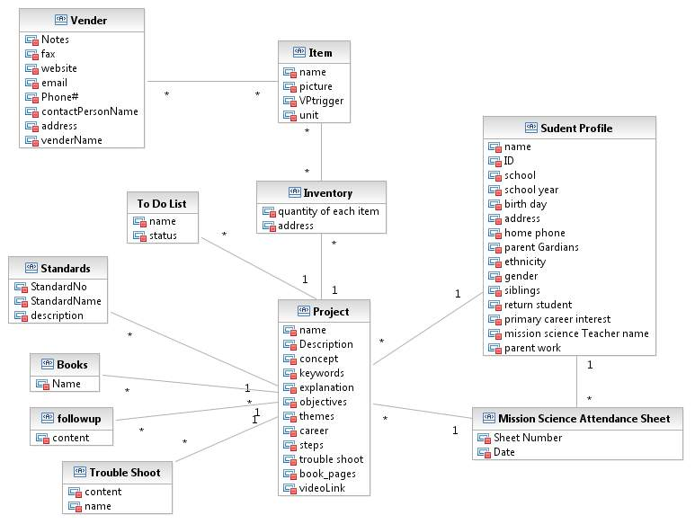
Figure 2: Artifacts and Information Diagram
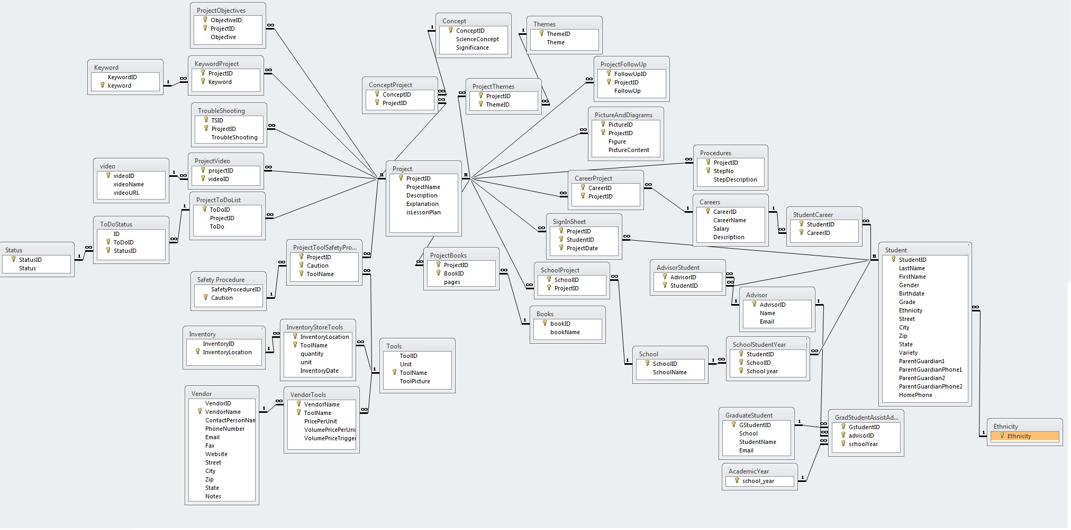
Figure 3: Entity Relation Diagram

Table 2 Artifacts and Information Summary
Artifact | Purpose
ATF1- Standards | Could be National and State Standards, describing the attribute of project
ATF2-Item | Materials used in the project showed in the inventory list. Contains price, amount, so that project can make use of it
ATF3- Project | Teacher will create a project by submitting Project form which includes keywords description , standards and so forth
ATF4- Inventory | Essentially maintain the amount of each items in each location, so that all user of the system  will know if items is still enough for lesson and experiment to continue
ATF5- Mission Science Attendance Sheet | Will contain information of student, project and enrolled year.
ATF6- Student Profile | Including student demographic information
ATF7- Books | Include book name, describe book that project refers
ATF8-Vender | Vender that provides and sales items.
ATF9- To Do List | Things that still needs to do for the project. Include name and status
ATF10-Followup | Include follow up content
ATF11-Trouble Shoot | Include name and content of trouble shoot for project

Behavior
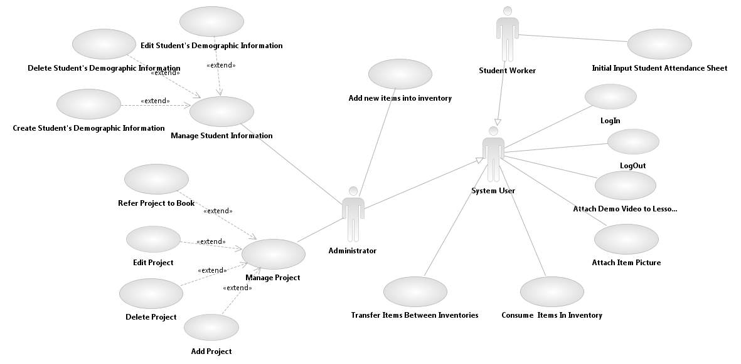

Figure 4: Process Diagram

Administrator System behaviors

Add Project
Table 3 Process Description-Add Project
Identifier | UC-1 Add Project
Purpose | Add Project
Requirements | WC_626 [Lessons] Want to be able to add lessons as new lessons are created  WC_625 From the lesson plan category, want the actual background information, standards aligned to keywords, picture, and how to do the lesson.
Development Risks | Checking if the required arguments are specified i.e. whether the topic is specified and it does not have the same name as any other. If its edit or delete, then checking if the lesson plan exists already
Pre-conditions | The user is an administrator user.  The user is logged into system.  System database is properly initialized.
Post-conditions | If the procedure process successfully, the Projects will be created in the databases
Table 4 Typical Course of Action-Create new project
Seq# | Actor’s Action | System’s Response
1 | Fill out Create Project
2 | Click Submit button
3 |  | Process & stores it in the database and shows a confirmation page or message and get back to the dashboard

Edit Project
Table 5 Process Description-Edit Project
Identifier | UC-2 Edit Project
Purpose | Edit Project
Requirements | WC_625 From the project category, want the actual background information, standards aligned to keywords, picture, and how to do the lesson.
Development Risks | Checking if the required arguments are specified i.e. whether the topic is specified and it does not have the same name as any other. If its edit or delete, then checking if the project exists already
Pre-conditions | The user is an administrator user.  The user is logged in to the system.  System database is properly initialized.
Post-conditions | If the procedure process successfully, the Projects will be modified in the databases
Table 6: Typical Course of Action- Edit project
Seq# | Actor’s Action | System’s Response
1 | Click on projects that need to be edited
 |  | Direct user to an edit page
2 | Modify project fields
3 | Click submit button
4 |  | Confirmation message and jump back to dashboard

Delete Project
Table 7: Process Description-Delete Project
Identifier | UC-3 Delete Project
Purpose | Delete Project
Requirements | WC_625 From the project category, want the actual background information, standards aligned to keywords, picture, and how to do the lesson.
Development Risks | Checking if the required arguments are specified i.e. whether the topic is specified and it does not have the same name as any other. If its edit or delete, then checking if the project exists already
Pre-conditions | The user is an administrator user.  The user is logged in to system.  System database is properly initialized.
Post-conditions | If the procedure process successfully, the Projects will be deleted in the databases
Table 8: Typical Course of Action- Delete project
Seq# | Actor’s Action | System’s Response
1 | Click on projects that need to be deleted
2 |  | Direct user to an delete page. Show the message are you sure you want to delete this?
3 | Click submit button
4 |  | Confirmation message and jump back to dashboard
Table 9: Alternative Course of Action- Incomplete Form
Seq# | Actor Actions | System Response
1 | Fill in some or no fields
2 | Click submit the form
3 |  | Check the completeness & uniqueness of the form.
4 |  | Reloads the form page, and using red tag to indicate the incomplete fields

Add student information
Table 10: Process Description – Add Student Information
Identifier | UC- 4: Add Student Information
Purpose | Add the student information and generate reports
Requirements | WC_633: From the student database, need the student demographic data
Risks | If students with same name and day of birth with be rejected by the system because logically it is the same person
Pre-conditions | The user is an administrator user.  The user is logged into system.  System database is properly initialized
Post-conditions | Add student data to the database successfully
Table 11: Typical Course of Action – Add Student Information
Seq# | Actor Actions | System Response
1 | Click on the add new student form
2 |  | Shows the form
3 | Enter all the data
4 | Click on the Submit
5 |  | Check for the validity. If valid. Process the form, show success message & return to the dashboard
6 |  | If not valid, show the fields in red, which are not valid
7 | If not valid update the info & follow from step 4

Edit Student Information
Table 12: Process Descriptions – Edit Student Information
Identifier | UC- 5: Edit Student Information
Purpose | Edit the student information and generate reports
Requirements | WC_633: From the student database, need the student demographic data
Risks | N/A
Pre-conditions | The user is an administrator use.  The user is logged into system.  System database is properly initialized.  The student steps into new grade.
Post-conditions | Get student data modified successfully in the database.
Table 13: Typical Course of Action – Edit Student Information
Seq# | Actor Actions | System Response
1 | Select option of edit from dashboard
2 |  | Show a textfield, to enter name of the student or a dropbox
3 | Enter the name of the student
4 | Click on the Submit
5 |  | Give a list with the radiobox of people with same name
6 | Select the radiobox
7 |  | Show the info as a form of the student
8 | Edit the information
9 | Click on submit
10 |  | Check for the validity. If valid. Process the form, show success message & return to the dashboard
11 |  | If not valid, show the fields in red, which are not valid
12 | If not valid update the info & follow from step 8

Delete Student Information
Table 14: Process Description – Delete Student Information
Identifier | UC- 6: Delete Student Information
Purpose | Delete the student information and generate reports
Requirements | WC_633: From the student database, need the student demographic data
Risks | N/A
Pre-conditions | The user is an administrator user.  The user is logged into system.  Database is initialized properly.
Post-conditions | Delete student data from database successfully.
Table 15: Typical Course of Action – Delete Student Information
Seq# | Actor Actions | System Response
1 | Select option of Delete from dashboard
2 |  | Show a textfield, to enter name of the student
3 | Enter the name of the student
4 | Click on the Submit
5 |  | Give a list with the checkbox of people with same name
6 | Select the checkbox of students you want to delete
7 | Click Delete
8 |  | Show success message and go back to dashboard

Refer project to book
Table 16: Process Description- Refer project to book
Identifier | UC-7 Refer project to book
Purpose | Link book with project so that project can have “experiment” activity
Requirements | WC_632: From the books/experiments categories, want the descriptions of the projects that are in the books, materials, pictures, standards, and key words (similar to WC 625)  WC_637: Want the books and project categories "linked" so that you have the ability at any site to determine if there are enough materials for any project (Related to 630). Want to be able to see whether or not there are enough materials without having to manually check.
Development Risks | Book should exist
Pre-conditions | User is logged in the system as an administrator.  Project has no book referred.
Post-conditions | Certain book and its book range will be linked to project
Table 17: Typical Course of Action-Refer project to Book
Seq# | Actor’s Action | System’s Response
1 | Select add the Book to project
2 |  | Form containing books and project is returned
3 | Link those 2 fields
4 | Press Submit button
5 |  | Process it, show success message and return to dashboard if no error, else show the form with red fields if any error
6 | Modify if any error and follow step 4

Generate Report
Table 18: Process Description-Generate Report
Identifier | UC-9 Generate Report
Purpose | To publish summary of student progress
Requirements | WC_644: Higher level access for Darin to be able to run queries/reports (either in Access interface or some easily maintainable interface)
Development Risks | The data should not be mixed and the results should be accurate
Pre-conditions | User is logged in the system.  Sufficient amount of data has been entered to feed the report
Post-conditions | Report with the criteria specified
Table 19: Typical Course of Action-Generate Report
Seq# | Actor’s Action | System’s Response
1 | Click Generate Reports button
2 |  | Popup the window of input box
3 | Input SQL statements
4 | Press confirm button
5 |  | Show the reports generated

User tasks

User Login
Table 20: Process Descriptions - Login
Identifier | UC- 10: Login
Purpose | Determine the role of user and display corresponding management screen to user
Requirements | WC_644: Higher level access for Darin to be able to run queries/reports (either in Access interface or some easily maintainable interface)
Development Risks | To see if this functionality is available in MS Access
Pre-conditions | User information already in the user database
Post-conditions | User is authorized with appropriate functions he can perform to the system
Table 21: Typical Course of Action – Login: Successful
Seq# | Actor Action | System Response
1 | System user Enters a user name and password
2 | Clicks Login button
3 |  | Check if the username and password match up with records in user table
4 |  | Redirect users to user center pages
Table 22: Alternate Course of Action – Login: Failure
Seq# | Actor Action | System Response
1 - 3 | Refer to typical course of action
4 |  | Displays An error message: “username or password is wrong” in a dialog box
5 | Clicks OK button
6 |  | Redirects the user to the login page

Logout
Table 23: Process Descriptions – Logout
Identifier | UC- 11: Logout
Purpose | To log out of the system
Requirements | WC_644: Higher level access for Darin to be able to run queries/reports (either in Access interface or some easily maintainable interface)
Risks | None
Pre-conditions | The User is logged in the system
Post-conditions | The User session terminated
Table 24: Typical Course of Action – Logout
Seq# | Actor Actions | System Response
1 | User clicks the “log out” button
2 |  | Kill the user object in system
2 |  | Display a message: “you have logged out of the system” in a dialog box
4 | Click OK button
5 |  | Redirect the Log in sheet

Transfer items between inventories
Table 25: Process Description-transfer items between inventories
Identifier | UC-12 transfer items between inventories
Purpose | Maintain inventory levels so that materials are available when necessary and ensure that complete shortage never occurs
Requirements | WC_628: From the inventory category, want to have quantity and location of each type of material/tool  WC_636: Want the inventory from the project and the book experiments database "linked" so that there is commonality between the terms.(Means Here we just need the materials would be inputted by Darin and the student worker will just select it)  WC_631: [Inventory] Store Vendor and pricing information  WC_630: [Inventory] Check in/check out system(Just want to know how may materials are available at a location)
Development Risks | Inventory location might be created not on purpose
Pre-conditions | User is logged in the system.  User is all system users.  Inventory database is up-to-date; each inventory maintains a list of items and its amount information.
Post-conditions | Inventory database will hold an updated count of each material item
Table 26: Typical Course of Action- transfer items between inventories
Seq# | Actor’s Action | System’s Response
1 | Log in to the system as a student user
2 | Access Inventory database
 |  | Display list of inventory items
3 | Click on inventory item to be transferred
4 |  | Select from location and to location
5 | Input amount needs to be transferred
6 | Click submit the form
7 |  | Display updated current count and picture of selected item just modified
Table 27: Alternative Course of Action- Incomplete Form
Seq# | Actor Actions | System Response
1 | Fill in some or no fields
2 | Click submit the form
3 |  | Check the completeness & uniqueness of the form
4 |  | Reload the form page, and using red tag to indicate the uncompleted fields

Consume items in inventories
Table 28: Process Description-consume items in inventories
Identifier | UC-14 Consume items in inventories
Purpose | Maintain inventory levels so that materials are available when necessary and ensure that complete shortage never occurs
Requirements | WC_628: From the inventory category, want to have quantity and location of each type of material/tool  WC_636: Want the inventory from the project and the book experiments database "linked" so that there is commonality between the terms.(Means Here we just need the materials would be inputted by Darin and the student worker will just select it)  WC_630: [Inventory] Check in/check out system(Just want to know how may materials are available at a location)
Development Risks | Amount might out of bound if student enters a unrealistic number
Pre-conditions | User is logged in the system.  User is system users.  Inventory database is up-to-date; each inventory maintains a list of items and its amount information.
Post-conditions | Inventory database will hold an updated count of each material item
Table 29: Typical Course of Action- transfer items between inventories
Seq# | Actor’s Action | System’s Response
1 | Log in to the system as a student user
2 | Access Inventory database
 |  | Display list of inventory items
3 | Click on inventory item to be consumed
4 |  | Select location
5 | Input amount needs to be consumed
6 | Click submit the form
7 |  | Display updated current count and picture of selected item just modified
Table 30: Alternative Course of Action- Incomplete Form
Seq# | Actor Actions | System Response
1 | Fill in some or no fields
2 | Click submit the form
3 |  | Check the completeness & uniqueness of the form
4 |  | Reload the form page, and using red tag to indicate the uncompleted fields

Attach item pictures
Table 31: Process Description- Attach picture to item
Identifier | UC-15 Attach picture to item
Purpose | Link item picture to item so that make it easy for student work to pick up right item in inventory
Requirements | WC_629: [Inventory] Want to have pictures of what each type of tool/material looks like so that new student workers/teachers can input inventory from the materials in the storage room
Development Risks | The picture might not show if it is not in a format that supported by our NDI product
Pre-conditions | User is logged in the system as a student worker.  Items in our database has no picture linked
Post-conditions | Items has a picture to show how it looks like
Table 32: Typical Course of Action- Attach picture to item
Seq# | Actor’s Action | System’s Response
1 | Log in to the system as a student user
2 | Access Inventory database
 |  | Display list of inventory items
3 | Click on inventory item to be link picture with
4 |  | Select from local file
5 | Click submit
6 |  | Display confirm information

Student Worker Tasks

2.1.3.3.1 Update student attendance using attendance sheet
Table 33: Process Description- Update student attendance using attendance sheet
Identifier | UC-13 Update student attendance using attendance sheet
Purpose | Record the records that in which year the student get enrolled based on the attendance sheet, for the user to organize the student information in a clear way.
Requirements | WC_640: Would like to be able to calculate the cost per student for the program. Just need to retrieve the data from everywhere. So that Darin can do a calculations  WC_635: For the sign in category, want projects the students work on cataloged by school year, site, project and teacher
Development Risks | Attendance sheet has invalidated format so that it will not be able to accepted to database
Pre-conditions | User is a logged in the system as a student worker.  Student information has already existed in the database. And the primary key for the attendance sheet is only.
Post-conditions | Student information database will be updated

Table 34: Typical Course of Action-Update student attendance using attendance sheet
Seq# | Actor’s Action | System’s Response
1 | Log into system as a student worker
2 | Access the project database
3 | Search for an activity by typing its name into a text field and clicking the submit button
4 |  | Display a list of activities that match the requested search
5 | Click on the project name
6 |  | Display a drop-down list of schools served by Mission Science
7 | Select the school from the drop-down list
8 |  | Show a list of students for that school
9 | Select the students who have completed the activity and click submit button
10 |  | Display the project name and an updated list of students who have completed that project
Table 35: Alternative Course of Action- Incomplete Form
Seq# | Actor Actions | System Response
1 | Fill in some or no fields
2 | Click submit the form
3 |  | Check the completeness & uniqueness of the form
4 |  | Reload the form page, and using red tag to indicate the uncompleted fields

NDI/NCS Interoperability Analysis

Introduction
In our “Feasible Evidence Document” we have described the evidence that we can use one COT to fully satisfy our win condition.
Our team is Single NDI team; we are using Microsoft Access 2010 as our COT product.

COTS / GOTS / ROTS / Open Source / NCS
Table 36: NDI Products Listing
NDI/NCS Products | Purposes
Microsoft Access 2010 | Manage the database and provide switchboard for implementing logic functions

Connectors
Since Mission science is a Single NDI project, Connector is not applicable to our team.

Legacy System
Since Mission science is a Single NDI project, Connector is not applicable to our team.

System Structure
Figure 5: Deployment Diagram
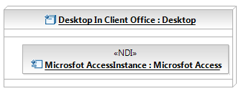

Figure 6: Software Component Diagram

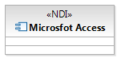
Figure 7: Hardware Component Diagram
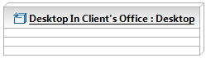

Evaluation Summary
Table 37: NDI Evaluation
NDI | Usages | Comments
Microsoft Access | 100% | Can satisfy client win condition.

